**LET’S GET TYING!!!**

*By Todd A.Schotts*

When people hear “Articulated” they get nervous or scared away from tying them. But actually they are really, really easy. The fly we are going to be tying is one of my favorite articulated flies, “The Feather Game Changer.” It is a smaller articulated fly than some of the original styles. Now for myself, I stayed away from tying these flies for the longest time, but once I started, they were so much fun. I naturally added my own flair to it, and these catch fish!! They have the same movement as jointed spin casting lures, which they also catch fish; that’s what makes these flies so popular.

The one thing to remember when tying these, the same step you do on the first segment, you repeat that same step on each section, getting bigger and bigger to create the visual aspect of a minnow.

One thing I have changed up on these flies, I use a segment from a mop piece for the tail in colors of brown, chartreuse, orange, or blue. The other major change I do is I like using “Off-Center” Bait Hooks. This gives the fly even more movement when stripping in. You can use any color of Hen Hackle, but I like using white, then if needed color with marker or markers to change its appearance. The filler (Polar Chenille, Cactus Chenille, or Chocklett’s Filler Material, or Chocklett’s Finesse Body Chenille) comes in different colors and sizes. Try to stay with the color as the hackle if possible and size to the size you are tying. Another trick I like doing is using Glo-Brite Floss when tying down the hackle. It shows up like crazy when the sun hits the flies; just another thing to entice the water inhabitants.

So get out your tools and take this awesome adventure of tying articulated flies to remove your fear of tying them.

Tight Lines and Snazzy Flies, Todd.

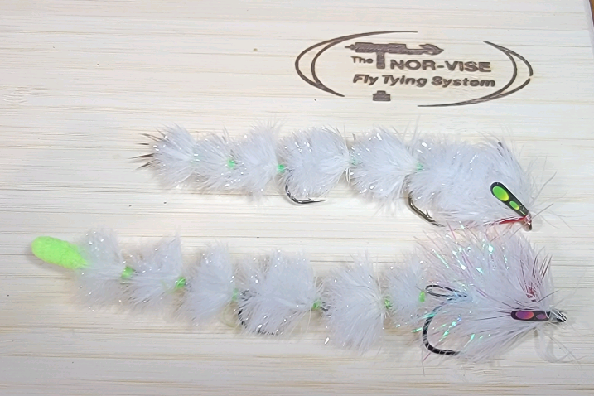

**MATERIALS:**

**Thread:** *140 Denier or 6/0 thread to match materials or white is good – I like starting out with white, then use Glo-Brite Floss when tying hackle down.*

**Shank 1:** *15mm Fish Spine*

**Tail:** *Mop Piece*

**Body:** *Polar Chenille or Cactus Hackle followed by Hen Saddle*

**Shank 2:** *15mm Fish Spine*

**Body:** *Polar* *Chenille or Cactus Hackle followed by Hen Saddle*

**Shank 3:** *15mm Fish Spine*

**Body:** *Polar Chenille or Cactus Hackle followed by Hen Saddle*

**Connection:** *Wire20lb or heavier (I use AFW Surflon 20lb Black-nylon coated steel wire)*

**Rear Hook:** *Ahrex Gammerus Size 6*

**Body:** *Polar Chenille or Cactus Hackle followed by Hen Saddle*

**Shank 4:** *20mm Fish Spine*

**Connection:** *15mm shank Clipped and secured to front hook*

**Front Hook:** *Partridge Attitude Extra Size 1 or Mustad 92641 Baitholder Off-Center Hook Size 1/0*

**Weight:** *.020 or .025 wrapped at bend of hook (optional)*

**Body:** *Cactus Hackle followed by Hen Saddle*

**Collar:** *Sparse Wraps of Red Schlappen (optional)*

**Head:** *Hen Hackle*

**Eyes:** *Hareline Real Fake Jungle Cock in colors*

**TODD SCHOTTS BIO:**

In case you are not familiar with me, here is my fishing report: I am a production tyer; I operate Grizzly Flies by Schottsie. Besides being a production tyer I have been a member of the Michigan Fly Fishing Club for many years now. I have served on the board in various positions, ran the Annual Smallmouth Outing for 11 years, the Muskegon River Outing, supplied articles for the Club’s Newsletter “The Evening Hatch” including the feature “Fly of the Month” for many years. I currently Chair the Guest Tyers for the Midwest Expo and organize tyers for our Activity Meetings. Besides all that I am also President of the ‘Huron River Fishing Association” and help out with a lot of their activities including the Bass Tournament, Carp Tournament, various outings, and help to organize their Christmas Silent Auction for the club members. I am a Team Member for Norvise, Pro-Staff for Anadromous Fly Tying Company, and on the Pro-Team for TFO Rods. Besides all of this, I still love chasing Bass, Panfish, Trout, Steelhead, and creating new amazing flies.