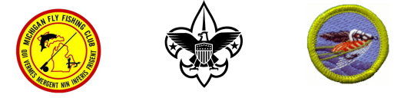
FLY FISHING MERIT BADGE
Presented By THE MICHIGAN FLY FISHING CLUB and BSA certified merit badge counselors.
Date- Sat. April 20, 2024
MFFC presents a fun-filled day learning all about fly fishing, following the Boy Scout Merit Badge requirements.
WHO: Registered Scouts BSA
WHERE: Multi-Lakes Conservation Assn., 3860 Newton Rd, Commerce Charter Twp., MI.
WHEN: April 20th-2024, 8:50 AM (sharp) to 5:00 PM.
COST: $20.00, prepaid to “MFFC” – until the class is filled. Deadline is April 18, 2024.
MB CLASS QUESTIONS: Dave Oakley 313-613-1262 / oak2153@yahoo.com
Registration starts January 6, you will receive confirmation of receipt via e-mail. Only Scouts, First Class rank or higher, that pre-register (payment and signed Permission slips) will be allowed to participate. Participation will be limited the first 40 Scouts (based on payment receipt) in order to ensure a quality experience. Walk-ins will be turned away. Please complete this page and mail with a check for $20.00
payable to: “Michigan Fly Fishing Club”, c/o David Oakley, 943 Liberty Ave., Lincoln Park, MI. 48146.
PARENT PERMISSION/REGISTRATION SLIP – PRINT LEGIBLY
Scout’s Name: Council: ______________________________________________ Troop # ______
Address: ________________________________________City____________________Zip___________ Activity: ___Merit Badge School Sponsored by the Michigan Fly Fishing Club_______
Date of Activity: ____April 20, 2024______
Are you Right Handed ____ or Left Handed _____ (please check one) PARENT AUTHORIZATION: The person herein described has permission to attend the above activity and to engage in all prescribed activities. In the event I cannot be reached in an emergency, I herein give permission to the physician selected by the Adult Leader in charge to hospitalize, secure proper anesthesia, or to order injection or surgery for my son. Signature: _______________________________ Date: ______________________________ (Parent or Guardian) Emergency Contact (name): _____________________ Cell Phone: ___________________ Email _____________________________________________________________________

FLY FISHING MERIT BADGE SCHOOL
ADDITIONAL INFORMATION WHAT TO BRING:
● Each troop or group must supply the proper amount of adult leadership.
● Merit badge application (blue card) signed by a Troop Adult Leader
● Your own food for the day. Thirty minutes is scheduled as a lunch break.
● Eye protection and head protection (sunglasses and billed caps).
DRESS: BSA field or activity uniform, and weather appropriate dress. The class will be held rain or shine
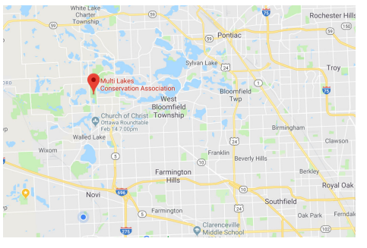
Scouts should obtain a copy of the Fly Fishing merit badge pamphlet and be prepared to discuss requirements 1, 7, 8, and 9 before arriving. Merit Badge Counselors will be on hand to certify each scout. Feel free to forward this notice to interested scouts.
