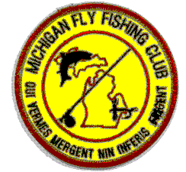April 6, 2024 8am to - 4pm

Outdoor Education Center

#### 3577 Sleeth Court

#### Commerce Twp., Michigan 48382

Gather with fellow MFFC members in an early season tune-up of your equipment, skills and luck on the Huron River at Proud Lake State Recreation Area. Thousands of Rainbow and Brown Trout planted by the Michigan DNR will test your cunning and catch and release skills. MFFC will host you at the Walled Lake Outdoor Education Center “Yurt” adjacent to the river, providing coffee, soft drinks, donuts and hot-stove conversation.

**>>>NOTICE<<<**

**A valid 2024 All-Species Michigan fishing license is REQUIRED to fish.**

**VISITORS WELCOME**

Intrigued by this “Fly Fishin’ Thing?” Come meet us and try your hand at our great sport. MFFC established 50 years ago, welcomes fascinated, the committed and the just plain curious for a day of early season fishing.

**DIRECTIONS**

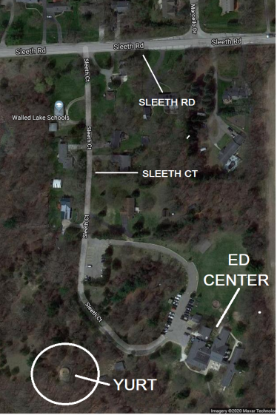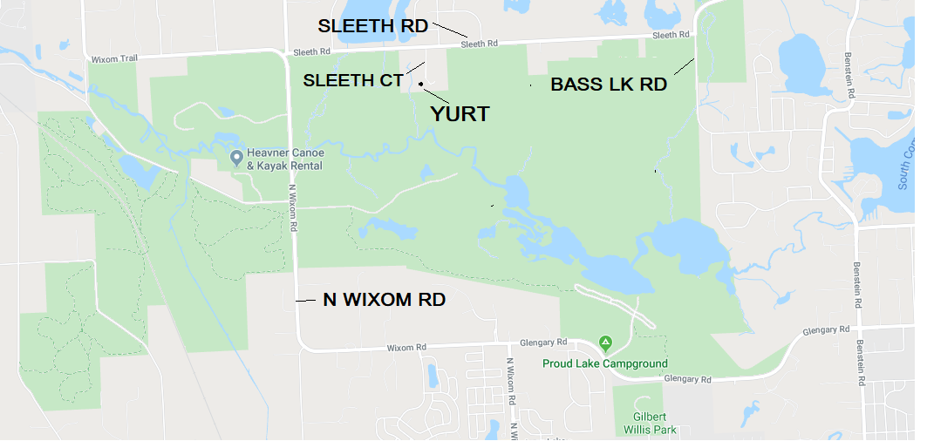The Walled Lake Outdoor Education Center and “Yurt” is located on the south side of Sleeth Rd mid-way between N Wixom Rd and Bass Lake Rd on Sleeth Ct. This is on the northern border of Proud Lake Recreation Area.