​**STOP# 5 of MFFC “NON-MEETING WEDNESDAYS ON THE WATER – SUMMER TOUR 2024”**

By Todd A. Schotts

Our next stop for our “Non-Meeting Wednesdays on the Water – Summer Tour 2024” will be taking place at in Ann Arbor at Gallup Park and is our Stop# 5. This is a 69-acre city ran park based on the Huron River and Geddes Pond. It consists of a boat house, walkways, and a boat ramp.

The park does offer at the boat house (just west of Huron River Parkway off of Geddes) fishing docks to fish on, bridges, shore lines and a pond to fish in. The boat ramp is located off of Geddes just east of Huron River Parkway. They offer the boat ramp, and have different areas to fish from shore.

The park does offer rentals, but you need to call ahead and do a reservation. Here is the number to call, 734.794.6240 if you are interested. If you are an Ann Arbor resident you will get a discount. Not sure on the hours of the rentals, but if you are interested, call the Livery number above and they can help you out.

One thing you may want to know, the Geddes Bridge by the Boat House is out, but the walkways are open. So, parking could be an issue, but there are plenty of other areas within walking distances or you also have the boat ramp location.

Myself and Ken will be at the boat ramp, since we will be launching our kayaks to fish around the areas within the park. There are various types of panfish, large mouth, smallmouth, pike, and carp you can have fun with. We will be keeping an eye out for everyone. Within this time of year, and way the summer has been going, I would recommend topwater flies should be top of the choices. Like poppers, Chernobyl ants, beetles, sneaky petes, and frogs. Then maybe streamers (big and small) and subsurface panfish flies.

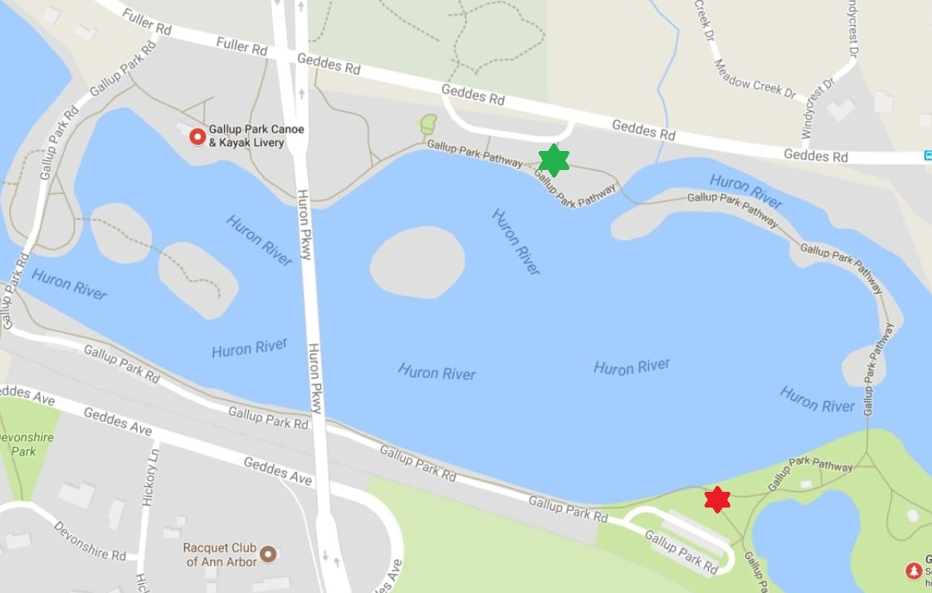

Boat Ramp

[Bridge out](https://www.bing.com/maps?q=galloup%20park,%20ann%20arbor&cvid=173a2b46843d4b8193afdebf62726a3b&form=WSBBST)