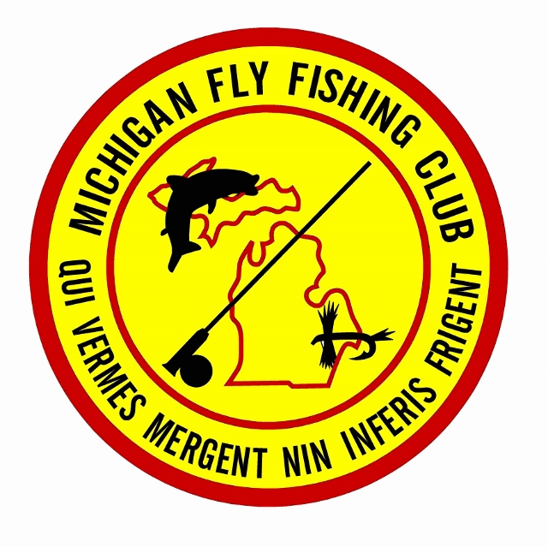2025 MFFC ARKANSAS TRIP #2

@ THE WHITE RIVER TROUT LODGE

MARCH 16th thru 21st, 2025

Attention MFFC Fly Fishers,

For 2025 The Michigan Fly Fishing Club will again host a 5-night, 4-day guided fly-fishing trip to the famed White River in the Ozark Mountains of Arkansas.

The trip will be a MFFC sanctioned trip in conjunction with guide Kelly Neuman and his crew from Streamside Custom Rod & Guide Service [www.arkansasstreamside.com]

The regular cost for 4 nights and 3 days of guided drift boat fly fishing is $1700, but for us, he has reduced the per person cost for 5 nights and 4 days of guided fishing to **$1500**.

This also will include lodging at the White River Trout Lodge on the banks of the White River, 3 meals (breakfast, lunch & dinner) per day, rods, flies and other essential equipment.

The cost for transportation to and from the lodge in Cotter, Arkansas will be our own responsibility.

At this time our trip date is set for mid-March (the following weekend after our Expo) and limited to **8** fly fishers. In addition, two anglers per boat is required.

**Arrive March 16th, Sunday, guided float trips Monday through Thursday (March 17, 18, 19 and 20) then depart for the return trip home, the morning of March 21st, Friday.**

The total cost for the trip will be broken into 3 payments, each with its own deadline.

**Deposit of $350 due on or before November 20, 2024 to reserve your spot.**

**2nd Payment of** **$400 due December 18, 2024 to make 50% deposit.**

**Final Payment of** **$750 due on arrival in Arkansas with our group.**

Payments can be made by cash or check to me, or credit card to Streamside. If for some reason you are unable to be at one of the deadline meetings, you can mail a check made out to me at my home address below.

**SIGN-UP BEGINS ON THE DAY OF THE SECOND CLUB MEETING IN OCTOBER (the 16th)!!**

To reserve your spot please feel free to telephone, email or see me at upcoming club meetings.

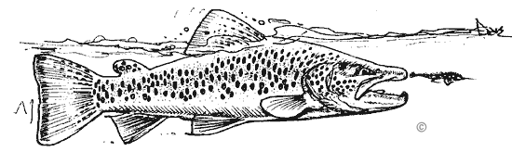

Jon Bada

2814 Walsh Dr.

Rochester Hills, MI. 48309

248-840-2983 - Cell

[vicepresident@mffc.org](mailto:sfree357@aol.com)